Memory Foam Feature Comparison

 | Ours | Tempur/Hill-Rom | Conventional memory foam | Notes
Foam appearance | 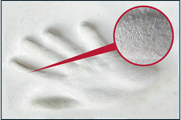 | 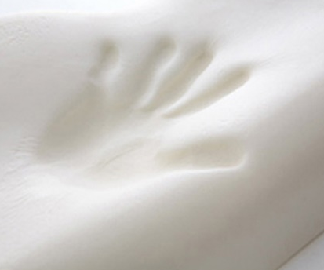 | 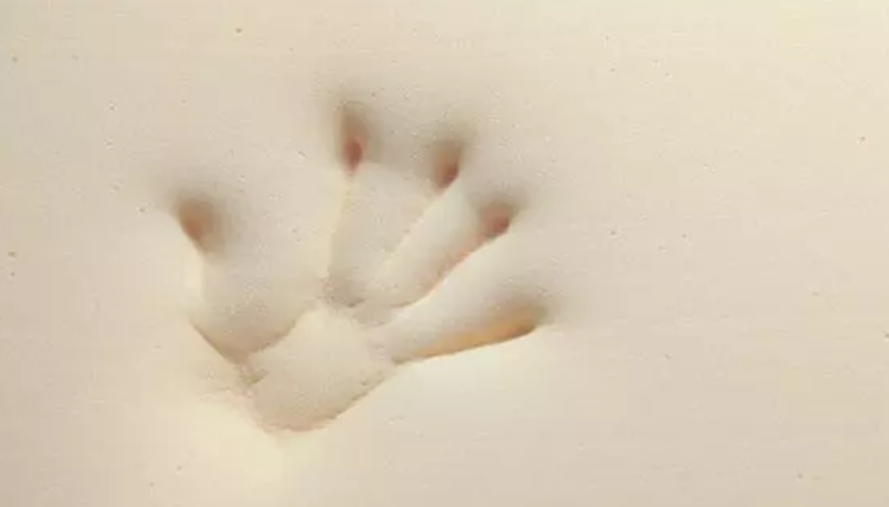 | Ours can reflect and ‘catch’ fingerprints.
Foam type | Viscoelastic foam | Viscoelastic foam | Ordinary foam | .
Manufacturing method | Molding production | Molding production | Continuous production | ---
Density | Around 93 kg/m³ | Around 85 kg/m³ | < 80 kg/m³ | The higher density, the better body contour and immersion the material supports to ensure comfort.
Structure | Open-cell structure  3D surface appealing  Increased strength and stiffness | Open-cell structure  3D surface appealing | Very soft slot layer | ---
Resposiveness | Slow rebound | Slow rebound | Relatively slow
Temperature Sensitiveness | Can adapt to temperature  Can finely-tuned to tailor to customer environment | Can adapt to temperature  Standard product, no tailor-made. | N. A.
Safety Standards and Certifications | Non-Toxicity (90 / 128 / EEC)  No Carcinogens (LGA TUV Rheinland)  Anti-bacterial (JIS L1902, AATCC147)  Flame Retardant  (FMVSS 302, CA 117)  Passed the Non heavy metal test by RoHS of European Union and SGS Lab Taiwan  Passed the anti-mite test of preventing method of Japan | Unknown | Unknown | ---
Manufacturing Process Specialty | Molding viscoelastic foams assembly process + multi-layers foams assembly process | Multi-layers process only | Multi-layers process only | In addition to multi layers process to combine air flow layer, pressure relief layer, and support layer, we develop special moulding process to assembly different viscoelastic material to support hip, back, legs, etc. to ensure better effectiveness and pressure relief.
Application | Home and Medical | Home and Medical | Home | ---
Warranty (Cover excluded) | Home: Mattress: 5 years; Pillow: 3 years  Medical Nursing: 2 years | Home: Mattress: 5 years; Pillow: 3 years  Medical Nursing: 2 years | N. A. | ---
Factory Certification | ISO9001, ISO13485, RoHS, CE, GP. | Unknown | ---
Origin of Production | Taiwan | Unknown

